 | OSP Social Media Resource  Module 1: The Power of Social Media Research

In this Ontario Skills Passport (OSP) Social Media Resource module, you will use social media to conduct research about your future career.

When it comes to discovering what you would like to do now and in the future, relevant industry blogs and social media accounts on Twitter, Facebook and YouTube (to name a few) are overflowing with information that can help you. This gives you up-to-the-minute information about the companies you are interested in working for and the industries you want to work in.



Work Smart: Stay Safe
Social media is a great tool to expand your opportunities for post-secondary education, volunteer work and employment. But like any tool it is important to take precautions to stay safe while you are using it. Before beginning these modules:

- Make sure your parents know what websites you are using before you start any social media networking.
- Check with your teacher or guidance counsellor for any additional school board policies that may apply in your area.
The Kids Help Phone website has some great online safety tips.

As a learner, the information you can access by social media can be extremely helpful when considering the many options you have for:

- Post-secondary courses  - Post-secondary programs  - Apprenticeship options  - Mentorships and Internships  - Scholarships  - Employment options  - Volunteer opportunities | 
The information you uncover through research will help you answer the four education and career/life planning inquiry questions in your Individual Pathways Plan: Who am I? What are my opportunities? Who do I want to become? What is my plan for achieving my goals? | 

As a job seeker, the more you know about a company including their industry, products, employees and their competition, the better.
- Doing social media research is particularly important when you are actively looking for a job or trying to find out more about the industry you would like to work in.  - Just like you use social media to stay connected to your friends, companies use social media to stay connected to theirs. For digital-savvy companies this includes their customers, suppliers, advertisers, investors and most important for you – their current and future employees. | 
Check out some of the companies you’re interested in working for and you will likely discover they are already using the web and social media to provide lots of different information.

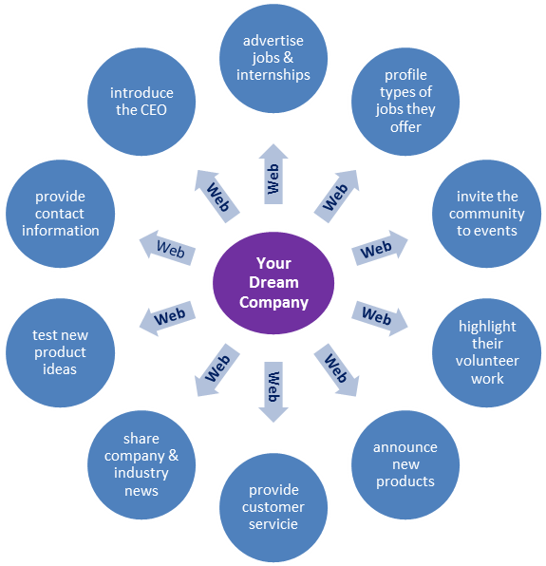

So, how can social media research work for you?
The purpose of the following activity is to show you how to use social media to find real-time information about a potential employer or an industry that you are interested in working with. The following instructions will guide you through the research process step-by-step.

 |  | The Power of Social Media Research | 
Your Name: _______________________________________
Date: __________________________
Step 1: Choose a Company
Find the website of a company that interests you and that has at least one social media account. Most companies with active social media accounts display them prominently on the home page of their website. You can also use your favourite search engine to find them by searching the company’s name together with the name of a social media site. For example: “Acme Investments Twitter”.
Enter the company name and website address for the social media account below.
Company name:
Website link:
Step 2: Review the Social Media Account
As you visit the company’s social media account, review what they have shared. Quickly jot down your first impressions in point form.
Type of social media (e.g. Twitter or blog):
How did you find this account?
Write down 3 things you notice about the account:
1.
2.
3.
Step 3: Analyze Three Social Media Posts
Choose 3 posts that tell you something about the company or the industry. A “post” can be anything – text only or could include pictures, videos or links to other industry websites. They may include information about jobs and internships, new products, events, customer service issues, etc.
For each of the posts complete the chart below
POST #1: Type of post
What is the post about?
What question could you ask about the post?

POST #2: Type of post
What is the post about?

What question could you ask about the post?
POST #3: Type of post
What is the post about?
What question could you ask about the post?
Step 4: Identify One More Source of Information
Look at who the company is connected with in their friends, followers or connections list. Are there any links to other companies or individuals you think will be a good source of information now or in the future? Enter the link below and explain your choice.
Company, person or organization name:
Weblink address:
Why do you think it will be useful?

Step 5: Go to the next page to complete the Reflection Sheet for this activity.

Reflection: The Power of Social Media Research
Your Name: _______________________________________
Date: __________________________
- Are you a regular social media user? If yes, what do you use it mostly for?

- Now that you have used social media to research an industry you are interested in, are you more or less interested in the industry? Explain your answer.

- After completing this activity, are you likely to use social media to prepare for job interviews or further research your career path? Why or why not?

- What is the most valuable piece of information you learned and why?

- As a result of your research, list two questions you can ask a parent, teacher or guidance counsellor that would help you plan for achieving your goals.

- How did this module help you answer your education and career/life planning inquiry questions: Who am I? What are my opportunities? Who do I want to become? What is my plan for achieving my goals?

Final Thoughts

Congratulations! You used many of your Essential Skills and work habits to complete the activities in this module.
 | When you conducted research on the social media accounts of different companies, you used your Computer Use, Reading and Finding Information skills.


 | When you chose three posts that gave you information about the companies, you used your Decision Making skills.
 | When you completed the Power of Social Media Research and Reflection worksheets, you used your Writing and Document Use skills.

 | Being a well-informed learner and job seeker shows you have Initiative and will set you apart from other applicants for a job or volunteer opportunity.
 | Completing your work on time shows you are Reliable.
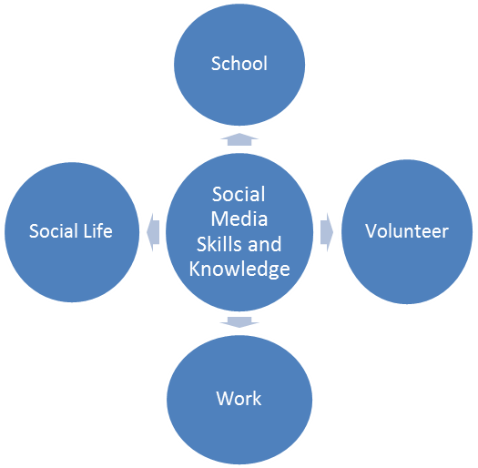
As you know from your work in the Ontario Skills Passport (OSP), one of the most powerful things about Essential Skills and work habits is the fact that they are transferable. Not only do they help you to excel at school, they also make you more effective in your volunteer, community and work life.
The information and ideas you work with in the OSP Social Media Resource are transferable in a similar way. As you work through the modules, you will learn how the social media skills, knowledge and technologies you use in your personal life for fun and to stay in touch with friends and family, also transfer to make you more effective as a student and more valuable as a volunteer and employee.

You can go to the OSP website at www.ontario.ca/skillspassport to search for tasks by occupation. Use the OSP Occupational Profiles to see how workers use their Essential Skills on-the-job. You can even do a self-assessment and compare your results to occupations of interest.
You can also access labour market information and employment opportunities on websites such as OnWIN and local volunteer opportunities on iWIN. |  | 
Skills ZONE has games and interactive resources to help you learn more about the Essential Skills and work habits important in work, learning and life. | 

Ready to learn more about using social media to showcase your Essential Skills and work habits to achieve your goals?
Go to OSP Social Media Resource Module 2: Creating Your Marketing Materials.

